Week 0

Name:Vishruthi KS

Roll no:241801318

Q1) Write an Algorithm and draw a Flowchart to Calculate the area and perimeter of a square.

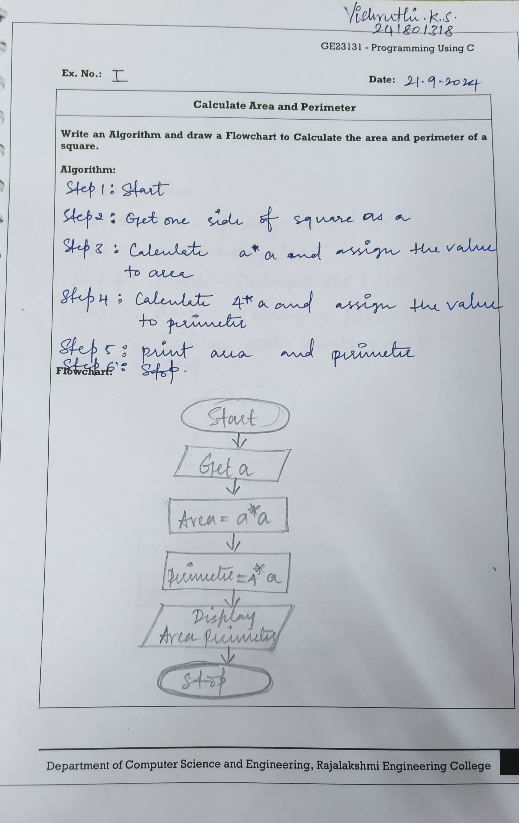Q2)Write an Algorithm and draw a Flowchart to convert the given days into years & months.

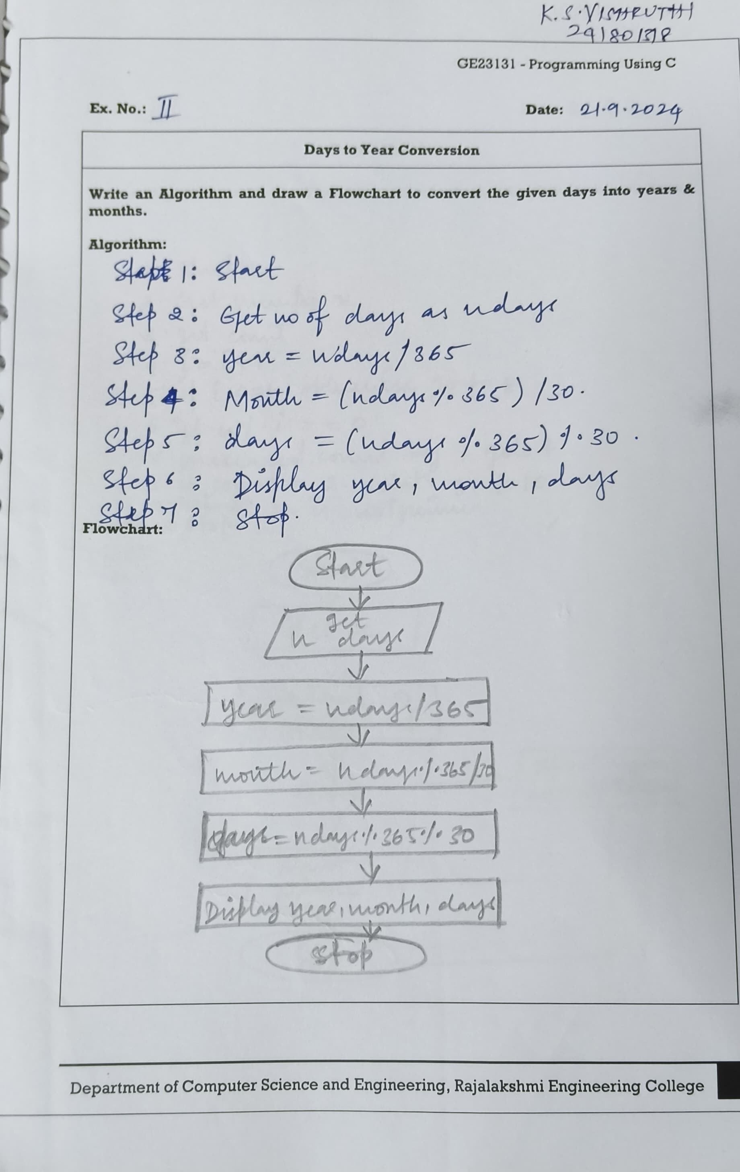

Q3) Write an Algorithm and draw a Flowchart to check whether the given number is Prime or not.

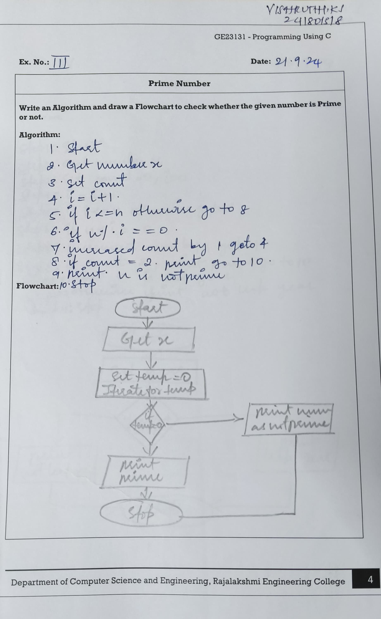

Q4) Write an Algorithm and draw a Flowchart to check whether the given year is Leap year or not.

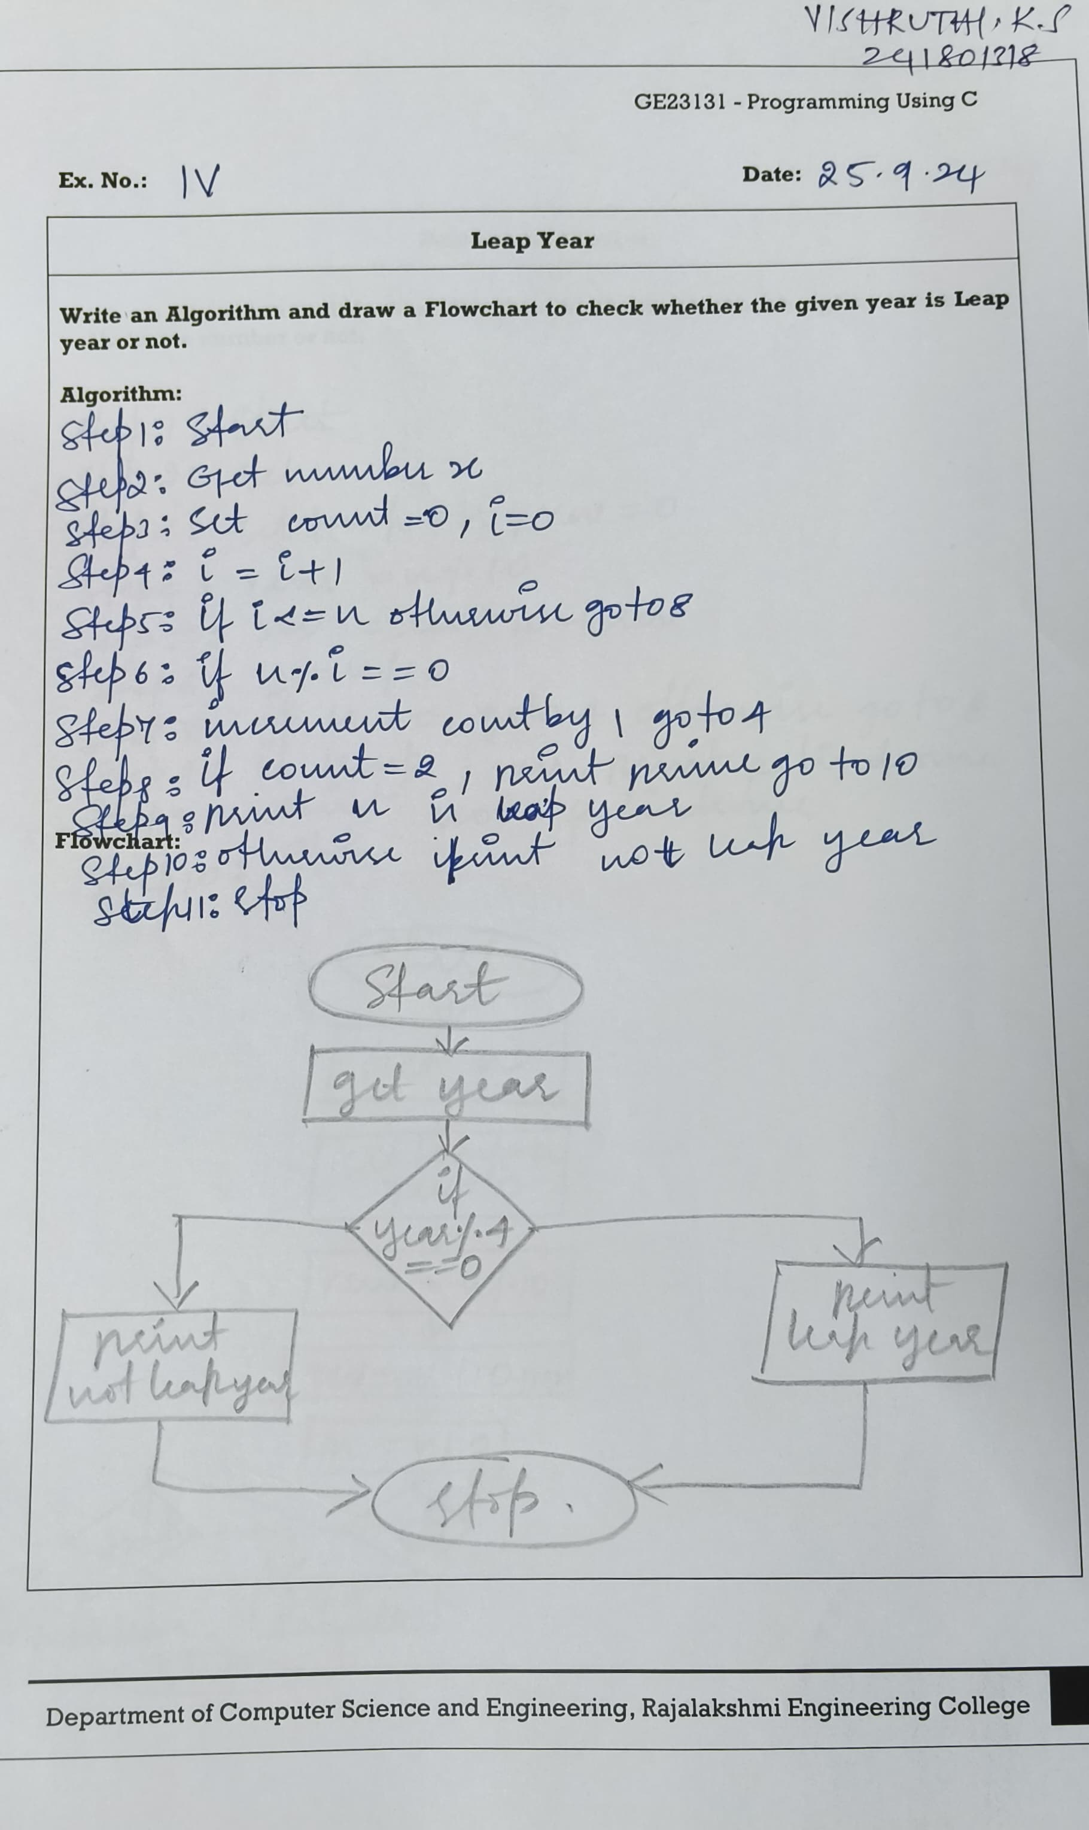

Q5) Write an Algorithm and draw a Flowchart to check whether the given number is palindrome number or not.

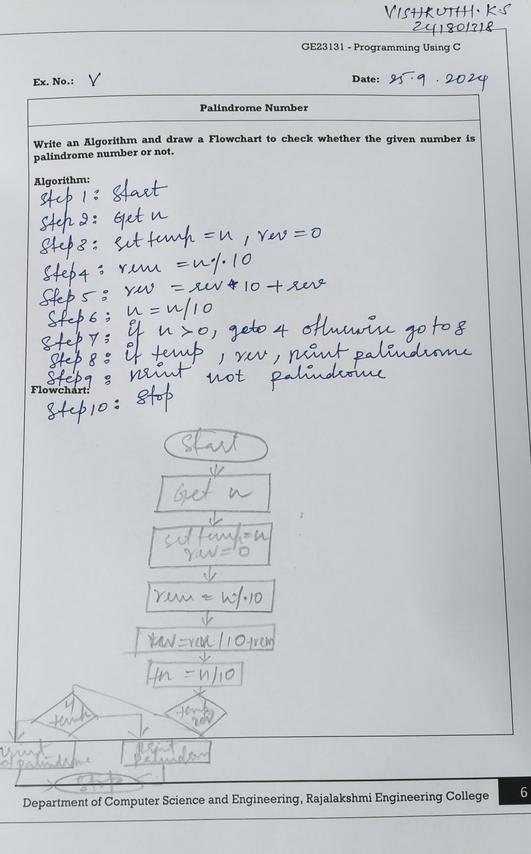

Q6) Write an Algorithm and draw a Flowchart to calculate the sum of digits in the given number.

